Create External Read & Write tables using File format(Delta, Parquet, JSON & CSV) & Supporting DML Operations
Notebook: Create External Read & Write tables (Delta, Parquet, JSON, CSV) & DML demo
1) Mount ADLS Gen2 (optional — choose method you prefer)
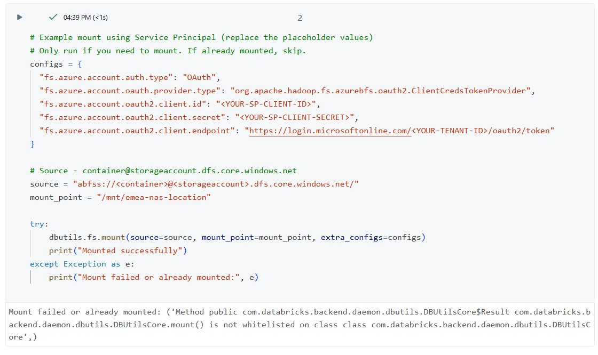

2) Create PySpark DataFrame from sample CSV(s), clean, and write out in 4 formats
# Databricks Python cell
from pyspark.sql import SparkSession
from pyspark.sql.types import StructType, StructField, StringType

# Define schema
schema = StructType([
StructField("employee_id", StringType(), True),
StructField("employee_name", StringType(), True),
StructField("Pincode", StringType(), True),
StructField("Contact_No", StringType(), True),
StructField("State", StringType(), True),
StructField("Country", StringType(), True)
])

# Sample data
data = [
("1001", "John Smith", "560001", "9876543210", "Karnataka", "India"),
("1002", "Priya Sharma", "400001", "9876500001", "Maharashtra", "India"),
("1003", "Michael Johnson", "94102", "9876500002", "California", "USA"),
("1004", "Emma Brown", "2000", "9876500003", "NSW", "Australia"),
("1005", "David Wilson", "10115", "9876500004", "Berlin", "Germany")
]

# Create DataFrame
df = spark.createDataFrame(data, schema)

# Path where Step 2 will read the CSV
output_path = "/mnt/emea-nas-location/sas-location/raw/employee_dir/"

# Write CSV file (overwrite if exists)
df.write.mode("overwrite").option("header", "true").csv(output_path)

print(f"Sample CSV created at {output_path}")
display(dbutils.fs.ls(output_path))

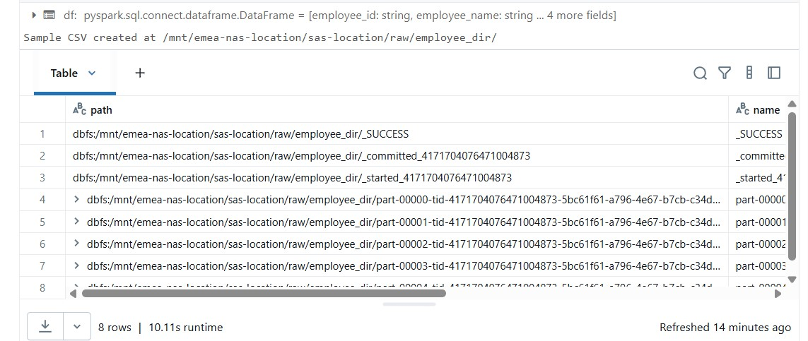
# Python / PySpark cell
from pyspark.sql.types import StructType, StructField, StringType
from pyspark.sql.functions import trim, regexp_replace, col, lit

schema = StructType([
StructField('employee_id', StringType(), True),
StructField('employee_name', StringType(), True),
StructField('Pincode', StringType(), True),
StructField('Contact_No', StringType(), True),
StructField('State', StringType(), True),
StructField('Country', StringType(), True),
])

# Adjust the input path to the folder containing input CSV(s)
input_path = "/mnt/emea-nas-location/sas-location/raw/employee_dir/*.csv"

df = spark.read.format('csv') \
.option("header", "true") \
.schema(schema) \
.load(input_path)

# Clean data: trim & remove quotes
clean_df = df.select([trim(regexp_replace(col(c), r'[\"\\\']', "")).alias(c) for c in df.columns])

display(clean_df.limit(10))
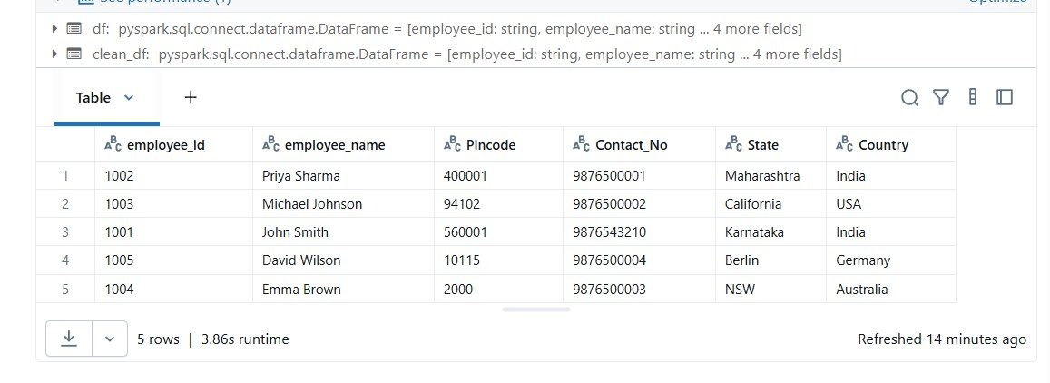
# Write out to Parquet, Delta, CSV, JSON (partitioned by Country)
base_out = "/mnt/emea-nas-location/sas-location/raw/employee_{}"

# Parquet
clean_df.write.format("parquet").partitionBy("Country").mode("overwrite")\
.save(base_out.format("parquet"))

# Delta
clean_df.write.format("delta").partitionBy("Country").mode("overwrite")\
.save(base_out.format("delta"))

# CSV (note: when writing partitioned CSV, subfolders created)
clean_df.write.format("csv").option("header","true").partitionBy("Country").mode("overwrite")\
.save(base_out.format("csv"))

# JSON
clean_df.write.format("json").partitionBy("Country").mode("overwrite")\
.save(base_out.format("json"))
print("Writes complete. Check the folders under:", base_out.format("*"))

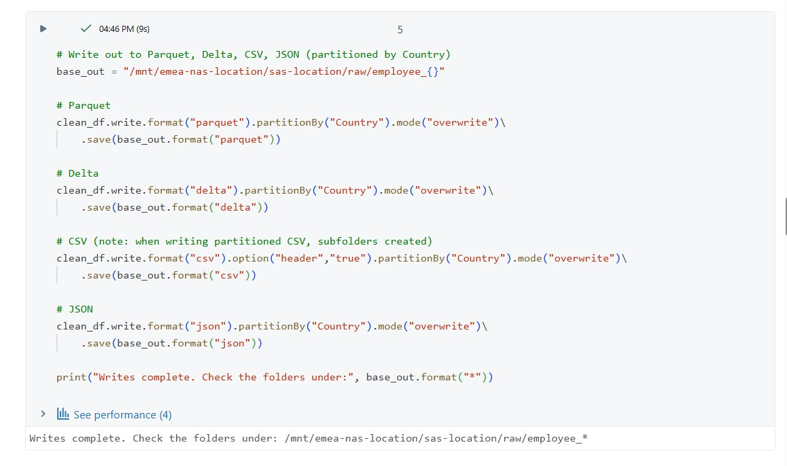
3) Use Hive Metastore (or Unity Catalog) — choose the right catalog/schema
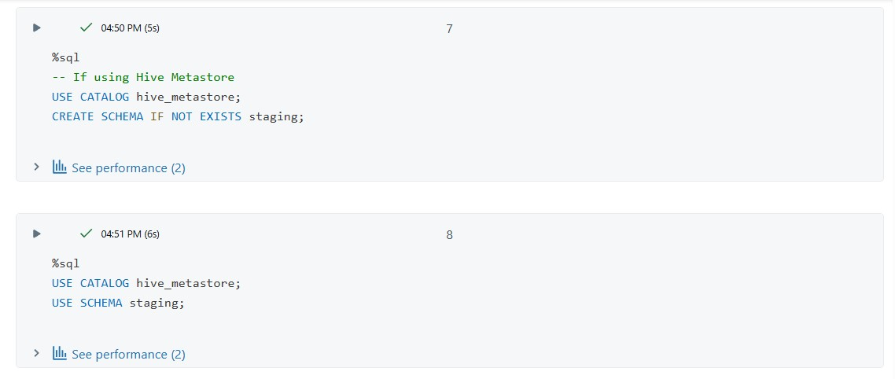

4) CREATE EXTERNAL TABLE (Delta) — using data source (recommended for Delta)
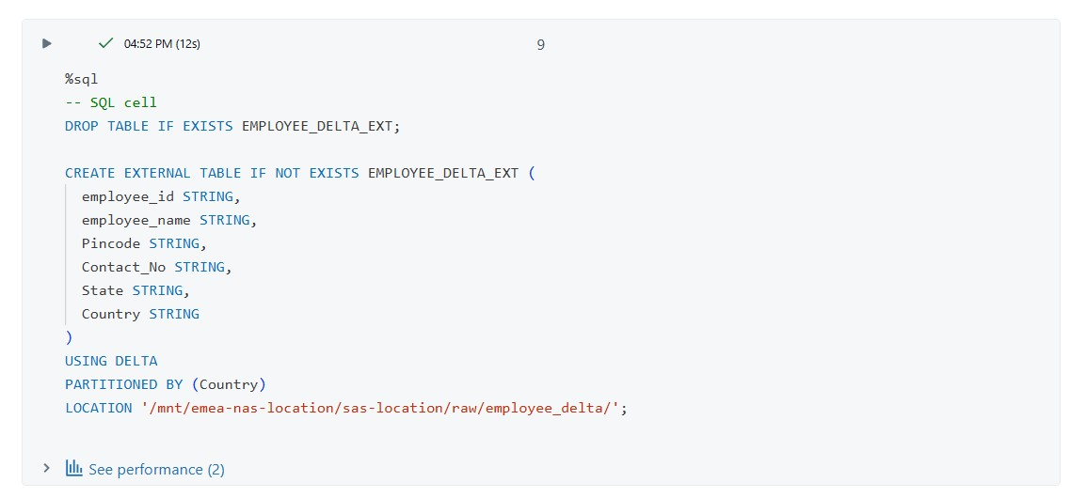

5) CREATE EXTERNAL TABLE (Parquet) — USING data source
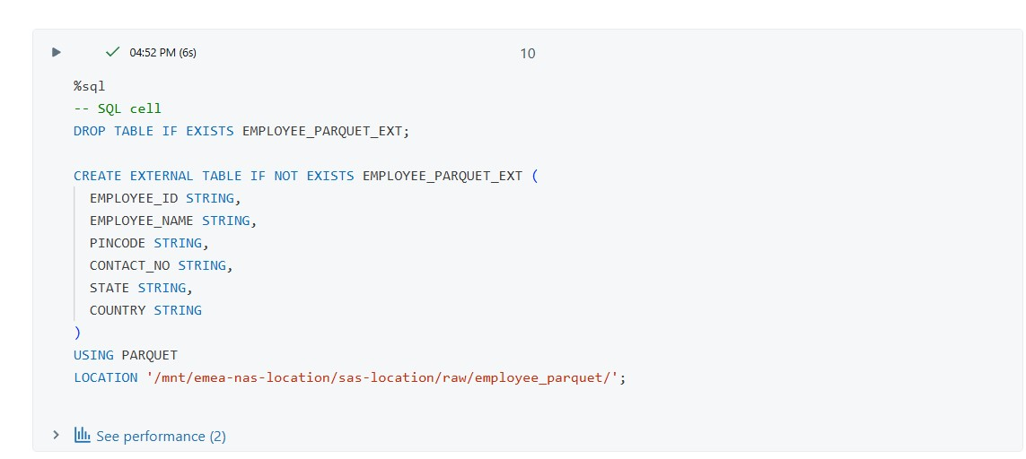
6) CREATE EXTERNAL TABLE (CSV)
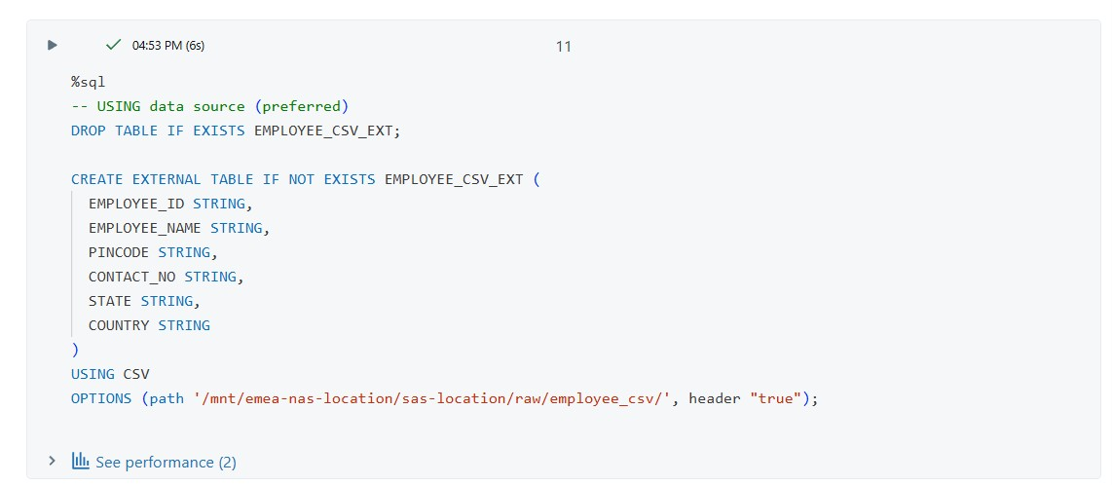
7) CREATE EXTERNAL TABLE (JSON)
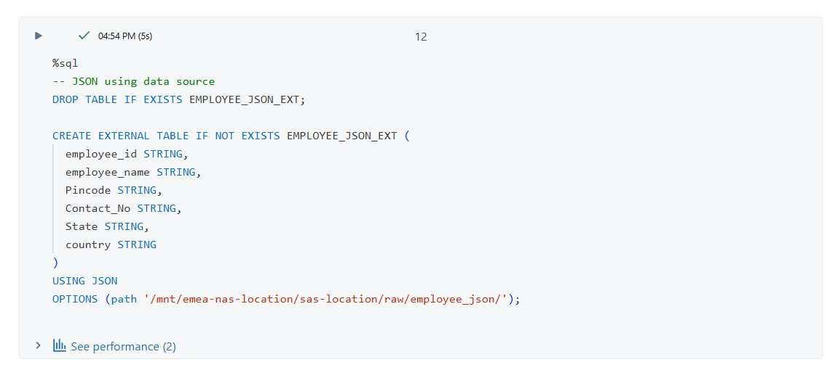

8) Verify reads (quick SELECT checks)
-- Try selects
SELECT count(*) FROM EMPLOYEE_DELTA_EXT;
SELECT * FROM EMPLOYEE_PARQUET_EXT LIMIT 10;
SELECT * FROM EMPLOYEE_CSV_EXT LIMIT 10;
SELECT * FROM EMPLOYEE_JSON_EXT LIMIT 10;
